**Assignment -1**

Python Programming

|  |  |
| --- | --- |
| Assignment Date | 19 September 2022 |
| Student Name | Anitta A |
| Student Roll Number | 951319104005 |
| Maximum Marks | 2 Marks |

**Question-1:**

Write a program which will find all such numbers which are divisible by 7 but are not a multiple of 5, between 2000 and 3200 (both included). The numbers obtained should be printed in a comma-separated sequence on a single line.

|  |
| --- |
| **Solution:** |
|  |  |

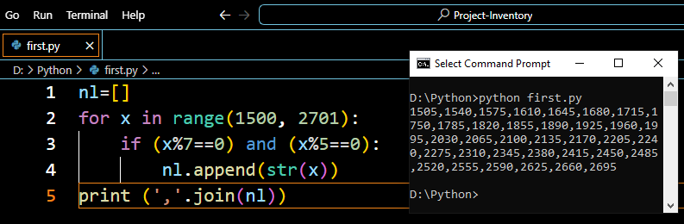

**Question-2:**

With a given integral number n, write a program to generate a dictionary that contains (i, i*i) such that is an integral number between 1 and n (both included). and then the program should print the dictionary.

|  |
| --- |
|  |

